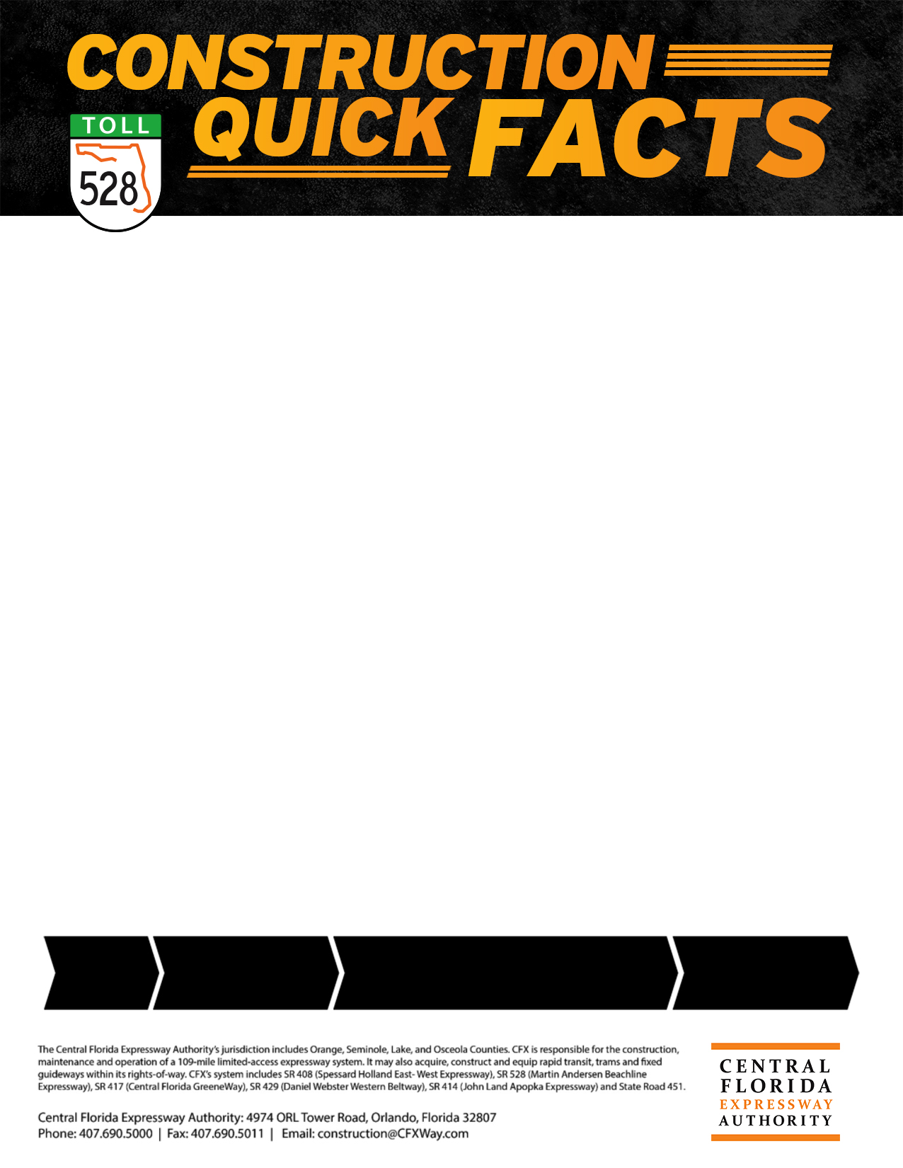

**PROJECT COST**

$17.8 million for construction

**Work zone safety**



For the safety of motorists and work crews, speed limits will be strictly enforced during construction. Speeding fines are doubled in work zones when workers are present. Motorists are reminded to change lanes for safety when they see Road Rangers assisting other motorists or flashing lights – it’s Florida law.

Distracted driving is a major cause of traffic accidents. Even just two seconds of distraction time doubles the chances of an accident. Use your cell phone when stopped and never text while driving. Instead, “Designate a Texter.” For details, click: [www.WhosYourDT.com](http://www.whosyourdt.com/).

Phone: 407-383-5817

E-mail: [construction@CFXway.com](mailto:construction@CFXway.com)

Website: [www.CFXway.com](http://www.CFXway.com)

Follow us on Twitter @DriveEPASS for current project information.

**LANE CLOSURES**



During construction, nighttime lane closures will take place between the hours of 8 p.m. to 6 a.m. to accommodate work. There will be daytime, nighttime, and occasionally weekend work performed on this project.

**Project map (reverse for large map)**

 

**PUBLIC INFORMATION**



For more information, contact the Public Information Officer:

Phone: 407-383-5817

E-mail: [construction@CFXway.com](mailto:construction@CFXway.com)

Website: [www.CFXway.com](http://www.CFXway.com)

Follow us on Twitter @DriveEPASS for current project information.

**PUBLIC INFORMATION**



For more information, contact the Public Information Officer:

Phone: 407-383-5817

E-mail: [construction@CFXway.com](mailto:construction@CFXway.com)

Website: [www.CFXway.com](http://www.CFXway.com)

Follow us on Twitter @DriveEPASS for current project information.

**Project: Sr 528 Econlockhatchee bridge replacement**



The [Central Florida Expressway Authority (CFX)](https://www.cfxway.com/) is scheduled to replace the dual bridges of the existing [State Road 528 (Martin B. Andersen Beachline Expressway)](https://www.cfxway.com/for-travelers/expressways/528/) over the Econlockhatchee River. The new bridges will be built at a high profile and will accommodate future widening (from two to three lanes in each direction). This 0.8-mile roadway construction project will include milling and resurfacing, drainage improvements, and utility relocation.

During construction, nearby residents and property owners may experience some noise, vibration and dust. The Central Florida Expressway Authority will take steps to minimize the impact of construction to the extent possible on the surrounding community.

The estimated cost of construction on this project is $17.8 million. Work is expected to be completed by late 2018.

**PUBLIC INFORMATION**



For more information, contact the Public Information Officer:

Phone: 407-383-5817

E-mail: [construction@CFXway.com](mailto:construction@CFXway.com)

Website: [www.CFXway.com](http://www.CFXway.com)

Follow us on Twitter @DriveEPASS for current project information.

**ESTIMATED COMPLETION**

Work is expected to take approximately 19 months and be completed in late 2018.

**PROJECT START**

Construction started in March 2017.

**QUICK**

**FACTS**

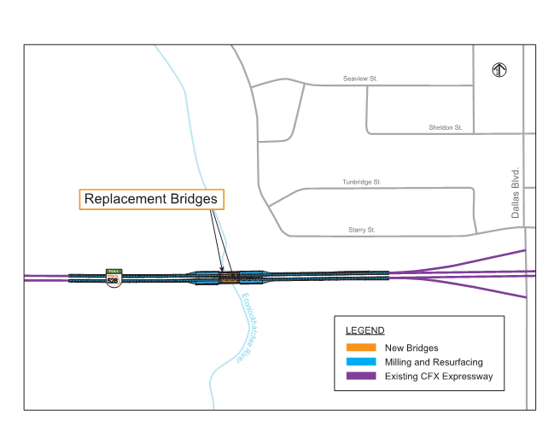

**SR 528 Econlockhatchee Bridge Replacement**