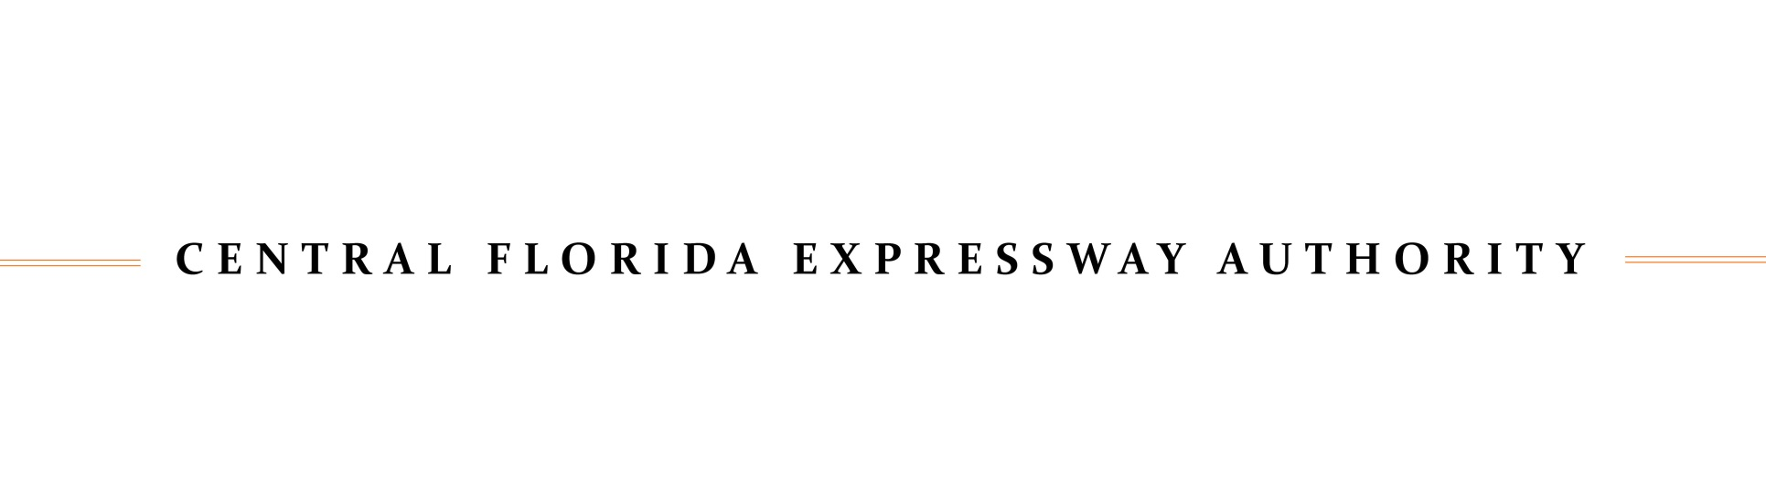

MINUTES
CENTRAL FLORIDA EXPRESSWAY AUTHORITY
RIGHT OF WAY COMMITTEE MEETING
September 24, 2025

Location: Central Florida Expressway Authority
4974 ORL Tower Road
Orlando, FL 32807
Boardroom

Committee Members Present:
Laura F. Carroll, City of Orlando Representative, Chairman (presided at opening)
Christopher Murvin, Citizen Representative, Chairman (assumed chairmanship during meeting)
Juan F. Diaz, Citizen Representative
Shane Fischer, Seminole County Representative
Anita Geraci Carver, Lake County Representative
Aida T. Ortiz, Orange County Representative
Paul Satchfield, Osceola County Representative

Committee Member Not Present:
Tad Calkins, Brevard County Representative

CFX Staff Present:
Michelle Maikisch, Executive Director
Mimi Lamaute, Recording Secretary/Manager of Executive and Board Services
Cristina T. Berrios, Deputy General Counsel
Glenn Pressimone, Chief of Infrastructure

A. CALL TO ORDER

The meeting was called to order at 2:00 p.m. by Chairman Carroll.

Chairman Carroll explained that according to the Right of Way Committee Charter, the Seminole County Representative is designated as the incoming Chairman.

Mr. Shane Fisher with Seminole County expressed appreciation for the nomination to serve as chair but declined the role, citing that as the newest member he has limited familiarity with the committee’s historical context and ongoing work. He recommended that the position be filled by someone with greater experience and familiarity with the committee’s activities, deferring to the next eligible nominee, Citizen representative Christopher Murvin.

A motion was made by Ms. Geraci Carver and seconded by Mr. Satchfield that Seminole County forgoes the current rotation as outlined in the Charter and nominates Citizen Representative Mr. Christopher Murvin as the incoming Chair. The motion carried unanimously with all seven (7)

Committee members present voting AYE by voice vote. One (1) Committee member, Mr. Calkins was not present.

At this time, Mr. Christopher Murvin assumed the role of Chair and presided over the remainder of the meeting.

B. PUBLIC COMMENT

There were no public comments or written public comments received by the deadline.

C. APPROVAL OF JULY 23, 2025 RIGHT OF WAY COMMITTEE MEETING MINUTES

A motion was made by Ms. Carroll and seconded by Ms. Ortiz to approve the July 23, 2025 Right of Way Committee meeting minutes. The motion carried unanimously with all seven (7) Committee members present voting AYE by voice vote. One (1) Committee member, Mr. Calkins, was not present.

D. AGENDA ITEMS

D.1. PROPOSED RESOLUTION OF CENTRAL FLORIDA EXPRESSWAY AUTHORITY ("CFX") DECLARING PROPERTY AS NECESSARY FOR ACQUISITION FOR EXPRESSWAY SYSTEM
PROJECT: SR 408 WIDENING PROJECT, SEGMENT 408-315; PARCEL: 31-805

Mr. David A. Shontz with Shutts & Bowen, LLP explained that CFX must acquire certain property interests to proceed with the SR 408 Widening project. The SR 408 project has two segments, 408-315, which is the Tampa Avenue interchange, and 408-315-A, which is the widening from US 441 to I-4. The project is located just west of I-4 and downtown Orlando. This is a perpetual easement totaling 9,499 square feet. This is for the construction of a sidewalk and associated improvements along Tampa Avenue, light pole and sign foundation, and for some grade harmonization between the back of the sidewalk and the remainder property, together with rights to inspect, repair, and maintain the improvements in the after condition.

Mr. Shontz is requesting approval of a resolution declaring the identified properties necessary for acquisition in accordance with Florida eminent domain laws and CFX procedures. An updated Legal Description was provided to the Committee and is attached hereto as Exhibit “A.”

The Committee members asked questions which were answered by Mr. Shontz.

A motion was made by Mr. Satchfield and seconded by Ms. Carroll for recommendation of Board approval and adoption of the Proposed Resolution Declaring Property as Necessary for Parcel 31-805 for the SR 408 Widening Project, as presented, subject to any minor or clerical revisions by legal counsel, General Engineering Consultant, or designee. The motion carried unanimously with

all seven (7) Committee members present voting AYE by voice vote. One (1) Committee member, Mr. Calkins, was not present.

D.2. PROPOSED SETTLEMENT AGREEMENT BETWEEN THE CENTRAL FLORIDA EXPRESSWAY
AUTHORITY (“CFX”) AND DAVIDSON KEG, LLC, DAVIDSON CRUISER, LLC, AND DAVIDSON
HARVEST, LLC IN THE MATTER OF CENTRAL FLORIDA EXPRESSWAY AUTHORITY V. CRA-
MAR GROVES, INC., ET AL., CASE NO.: 2023-CA-002713 FOR ALL CLAIMS RELATED TO
PARCELS 51-132A-C AND 51-832, INCLUSIVE OF ALL ATTORNEYS' FEES AND OWNER’S
EXPERT COSTS, PROJECT: SR 516 LAKE/ORANGE EXPRESSWAY
PARCELS: 51-132 A-C AND 51-832

Mr. David A. Shontz with Shutts & Bowen, LLP provided background on four parcels required for the SR 516 project, located within Segment 2. He reminded the Committee that SR 516 is a new four-lane limited access expressway which runs from SR 429 in West Orange County to US 27 in Lake County. The project totals 4.4 miles in length. The SR 516 project is divided into three segments. The subject property before the Committee today is located in Segment 2, or what's referred to as 516-237, which is approximately 1.9 miles.

The parcels being discussed today are owned by the Davidson entities, the CFX board adopted a resolution authorizing the acquisition of three of the four parcels.

Following mediation and negotiations, CFX and the property owners reached a full settlement for $44,835,860, inclusive of all fees, costs, and claims related to the parcels. The agreement also includes non-monetary terms addressing access, easements, and construction timelines for CR 455.

The Committee members asked questions which were answered by Mr. Shontz.

A motion was made by Ms. Geraci-Carver and seconded by Ms. Carroll for recommendation of Board approval and adoption of the Resolution Board approval of the Settlement Agreement between CFX and Davidson Keg, LLC; Davidson Cruiser, LLC; and Davidson Harvest, LLC for a negotiated total compensation in the amount of $44,835,860 for all claims related to Parcels 51-132A, 51-132B, 51-832 and 51-132C, inclusive of all attorneys’ fees and owner’s expert costs, and authorization to the Executive Director or designee to execute all documents necessary to complete the transaction, with the authority to approve any non-substantial changes by legal counsel. The motion carried unanimously with all seven (7) Committee members present voting AYE by voice vote. One (1) Committee member, Mr. Calkins, was not present.

E. OTHER BUSINESS

There was no other business discussed.

Chairman Murvin stated that the next Right of Way Committee Meeting is scheduled for November 19, 2025.

F. ADJOURNMENT

Chairman Murvin adjourned the meeting at 2:36 p.m.

Minutes approved on November 19 , 2025.

Pursuant to the Florida Public Records Law and Central Florida Expressway Authority Records and Information Management Program Policy, audio tapes of all Board and applicable Committee meetings are maintained and available upon request to the Custodian of Public Records at (407) 690-5326, publicrecords@CFXWay.com or 4974 ORL Tower Road, Orlando, Florida 32807.

